DFWHC Foundation led CHC receives funding from The Texas Health and Human Services Commission to provide Mental Health First Aid to residents of Twelve Counties in the North Texas Region
Through this funding, the Dallas-Fort Worth Hospital Council Foundation led CHC will be providing MHFA training to residents from Ellis, Erath, Grayson, Hood, Hunt, Johnson, Kaufman, Navarro, Parker, Rockwall, Somervell and Wise counties.
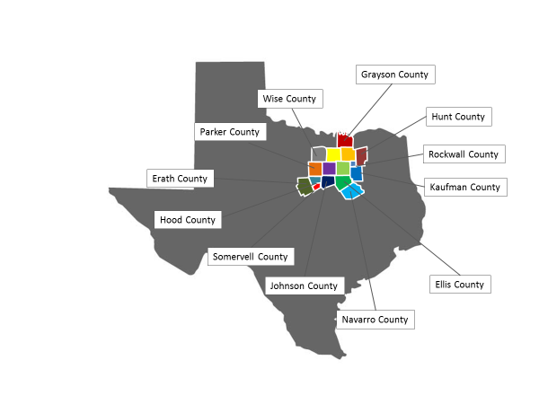
Selection of high behavioral health difficulty areas (zip codes) are based on our recent behavioral health needs assessment for 16 counties. The key strategy for selection of population and program planning will be to collaborate with trusted local community partners like local mental health authorities (LMHA’s), faith-based organizations, community leaders, law enforcement professionals, first responders, teachers, veterans (including their families) and residents in high behavioral health disparity areas to identify neediest individuals.
Providing culturally competent and literacy level appropriate MHFA (adult and youth as appropriate) training to these individuals will serve as a sustainable solution in local communities for early detection and prevention of mental health difficulties our rural counties, said…...
Through this program, CHC will also connect these communities with the behavioral health related provider resources available to them. CHC’s behavioral health resource list for 16 Counties is available on this website.
Chaired by Lisa Boone of MHMR of Tarrant County and Ashley Rodriguez of Baylor Scott and White Health, the CHC’s Mental Health First Aid committee is committed to training 10,000 north Texans in MHFA over three years period.
The Texas Health and Human Services Commission is awarding up to $15 million in grant funds to 31 governmental entities and nonprofit organizations located across the state to provide mental health services to communities.
In 2017, Rep. Four Price's House Bill (H.B.) 13 established HHSC's Community Mental Health Grant Program and provides $30 million in state funds over the 2018-19 biennium to be matched by grantees with local and private funds.

